Christopher Nkunku: A Talent Exploding on the World Stage
Christopher Nkunku, a 23-year-old French football player, has been making waves in the football world with his exceptional skills and talent. Born on November 14, 1997, in Lagny-sur-Marne, France, Nkunku started playing football at a very young age. His passion for the sport and dedication to training have led him to become one of the most promising players in the game today.

Nkunku's International Prospects: A Potential French National Team Star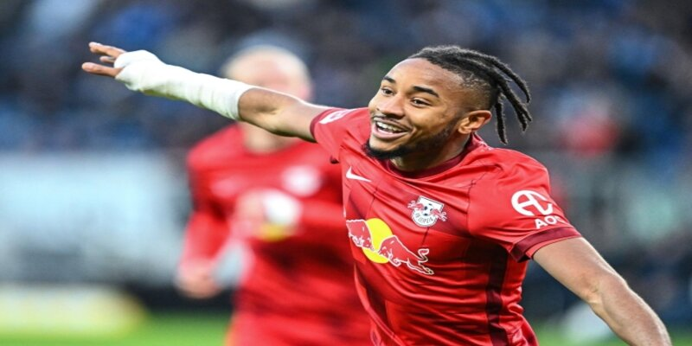
Nkunku's International Prospects: A Potential French National Team Star

At the age of 15, Nkunku joined the youth academy of Paris Saint-Germain, one of the biggest clubs in Europe. He quickly rose through the ranks and made his professional debut for PSG at the age of 18 against Bastia in the French Cup. The following season, he made his UEFA Champions League debut, becoming the youngest player to feature in the competition for PSG.
Nkunku's impressive performances at the youth level did not go unnoticed by the French Football Federation (FFF). He made his debut for the French U19 team in 2016 and went on to represent the U20 and U21 teams as well. He was a crucial member of the U21 team that won the European Championship in 2019.
With such a successful career at the youth level, it is only a matter of time before Nkunku breaks into the senior national team. He has already been called up for the French national team in March 2021 but did not make an appearance due to injury. However, with his consistent performances for RB Leipzig and his versatility on the field, Nkunku is poised to become a regular in the French national team in the near future.

The Versatile Midfielder
Nkunku's versatility is one of the key reasons why he is attracting the attention of top clubs and national teams. He is primarily a central midfielder but can also play as a winger or attacking midfielder. His technical skills, vision, and passing ability make him an effective playmaker, while his pace and dribbling skills make him a threat on the wing.
At RB Leipzig, Nkunku has been a vital player in the team's success. In the 2020-21 season, he contributed 10 goals and 13 assists in all competitions, helping RB Leipzig secure a second-place finish in the Bundesliga and reach the semi-finals of the UEFA Champions League. His versatility allows him to adapt to different styles of play and contribute to the team's success in various positions on the field.

Comparisons to French Legends
With his impressive performances and potential, Nkunku has drawn comparisons to some of the French football legends. His playing style has been likened to that of Paul Pogba, who plays in a similar role for the French national team. Nkunku himself has expressed admiration for Pogba and stated that he looks up to him as a role model.
Moreover, Nkunku's development at PSG has also drawn comparisons to Kylian Mbappé, another French superstar who made his breakthrough at the Parisian club. Both players have come through the youth academy at PSG and have gone on to achieve success at the highest level. Nkunku's potential has caught the attention of Mbappé, who has praised him for his talent and work ethic.

The Future of Nkunku: Premier League Dreams and World Cup Ambitions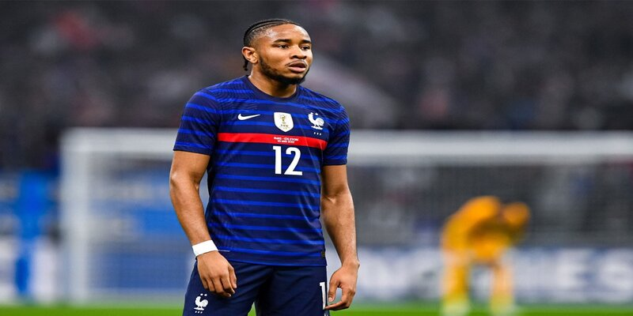
The Future of Nkunku: Premier League Dreams and World Cup Ambitions
Nkunku's impressive performances have not gone unnoticed by top clubs in Europe. In 2019, he made a move to RB Leipzig, where he has continued to develop and establish himself as one of the key players in the team. However, rumors have surfaced that several English Premier League clubs are interested in signing Nkunku, including Arsenal and Manchester United.

A Potential Move to the Premier League
The Premier League is known for its fast-paced and physical style of play, which could suit Nkunku's style of play. His pace, agility, and technical abilities would make him an asset to any team in the league. Moreover, with the financial power of Premier League clubs, it would not be surprising to see Nkunku make a big-money move to England in the future.
Nkunku himself has expressed interest in playing in the Premier League, stating in an interview, "I always have the objective of playing in the best championships, the Premier League is a championship that attracts me." With his contract at RB Leipzig running until 2024, it remains to be seen if a move to England will happen anytime soon.

World Cup Ambitions
Playing in the FIFA World Cup is every football player's dream, and Nkunku is no exception. With France being one of the top national teams in the world, competition for a place in the squad is tough, but Nkunku is determined to make it to the biggest stage of international football.
In an interview, Nkunku expressed his ambition to play in the World Cup, saying, "It's a dream for every young player, and I'm working towards it." With the next World Cup scheduled in 2022, Nkunku will have another opportunity to impress the French national team coach and earn a spot in the squad.

Conclusion
Christopher Nkunku's rise in the world of football has been nothing short of remarkable. From starting his career at PSG to becoming a key player for RB Leipzig and on the verge of breaking into the French national team, Nkunku's journey is an inspiration to young footballers. With his versatility, technical skills, and determination, he has all the qualities to become a star on the world stage. As he continues to develop and reach new heights, we can only expect more great things from this talented player.

